**WORKSHEET-1.2**

# Student Name: Rahul maurya UID:20BCS7260

**Branch: BE-CSE Section/Group-716“A”**

**Semester: 4th Date:04/03/22**

**Subject Name: MPI Sub Code: 20CSP-253**

## Aim/Overview of the practical:

### Add two 16 bit number.

1. **Task to be done:**

We have to add two 16 bit number and store them in a memory.

1. **Apparatus/Simulator used**

### JUBIN

* 1. JAVA

1. **Algorithm/Flowchart (For programming based labs):**

|  |  |
| --- | --- |
| LHLD 5000H | //LOAD THE DATA FORM MEMORY PAIR |

|  |  |
| --- | --- |
| XCHG | // EXCHANGE THE DATA OF HL WITH DE |
| LHLD 5004H | // LOAD DATA FROM THE MEMORY PAIR IN HL |
| MVI C, 00H | // MOVE 00HH TO C |
| DAD D | // ADD THE NUMBERS |
| JNC LABLE | // IF THERE IS NO CARRY THEN JUMP TO THE LABLE |
| INR C | // IF ANY CARRY IS THERE THE INC THE CARRY |

MOV A,C // MOVE CARRY TO THE ACCUMULATOR STA 5006H // STOR THE ACCUMULATOR VALUE AT 1006h LABLE: SHLD 5004H // STORE THE ANS AT 1004H

HLT //STOP TO CHECK FURTHUR INSTRUCTIONS

## Result/Output/Writing Summary:

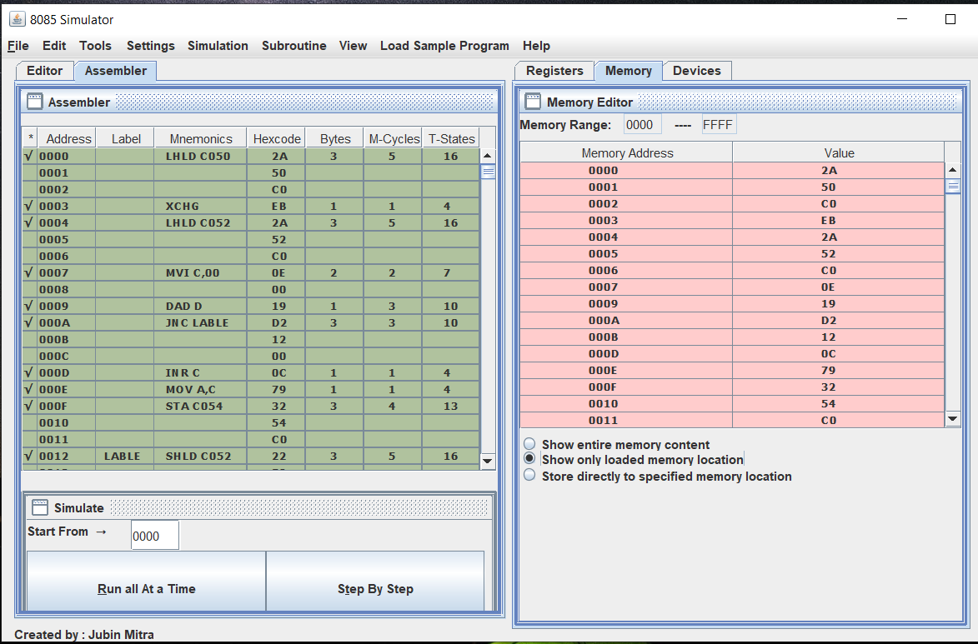

**Evaluation Grid (To be created as per the SOP and Assessment guidelines by the faculty):**

|  |  |  |  |
| --- | --- | --- | --- |
| Sr. No. | Parameters | Marks Obtained | Maximum Marks |
| 1. |  |  |  |
| 2. |  |  |  |
| 3. |  |  |  |
|  |  |  |  |